**EFFC ANNUAL GENERAL MEETING PROGRAMME**

**ROME, ITALY 2nd OCTOBER – 5TH OCTOBER 2024**

**WHY ROME?**

Known as the ‘Eternal City’ the Italian Capital of Rome is like no other, with its rich culture, long history, and incredible artistic heritage making it a special place that offers a huge variety of experiences.

Built in 753 BC, Rome truly highlights how Italy has historically become a melting pot of traditions and empires.

Over the years Architects along with painters and sculptors flocked to Rome and created many of the landmark pieces of architecture that make the city what it is today.

**TRAVELING TO ROME**

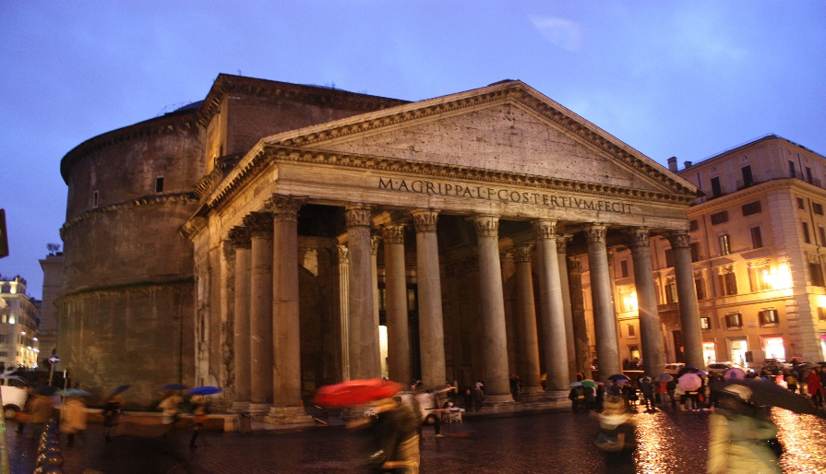

[This Photo](https://commons.wikimedia.org/wiki/File:Pantheon,_Rome_by_night.JPG) by Unknown Author is licensed under [CC BY-SA](https://creativecommons.org/licenses/by-sa/3.0/)

From Rome’s main airport Leonardo da Vinci International Airport (Fiumicino - FCO) there is approximately a 30-to-40-minute taxi drive to the 4-star H10 Roma Città, where the meetings will take place.

Alternatively, you may prefer to take public transport, where you can take the FL1 train to Trastevere, then the 170 bus to Meucci followed by a short walk from here to the hotel.

**EVENT PROGRAMME**

**WEDNESDAY 2ND OCTOBER**

**EFFC SECRETARIES MEETING – Part 1 – (open to secretaries & national co-ordinators only)**

* **Time:** 13.00 – 17.00pm
* **Location:** H10 Roma Città, Via Amedeo Avogadro, 35, 00146-Quartiere Marconi, Rome

**DINNER – Delegates shall take a Taxi to nearby Trastevere and walk around the district with our hosts to**   **find a restaurant.**

**THURSDAY 3RD OCTOBER**

**EFFC SECRETARIES MEETING – Part 2**

* **Time:** 09.00am – 12.00pm
* **Location:** H10 Roma Città, Via Amedeo Avogadro, 35, 00146-Quartiere Marconi, Rome

**EFFC BUFFET LUNCH**

* **Time:** 12.00-13.00
* **Location:** H10 Roma Città, Via Amedeo Avogadro, 35, 00146-Quartiere Marconi, Rome

*This lunch is open to Officers and full EFFC Members only.

**EXECUTIVE MEETING AND ANNUAL GENERAL MEETING - PART ONE (FOR CONTRACTOR MEMBERS ONLY*)**

* **Timings:**  13.00-18:30
* **Location:** H10 Roma Città, Via Amedeo Avogadro, 35, 00146-Quartiere Marconi, Rome
* *This meeting is open to full EFFC Members only and not Associate Members.

**WELCOME DINNER**

* **Timings:** 19.30-22.00
* **Location:** H10 Roma Città, Via Amedeo Avogadro, 35, 00146-Quartiere Marconi, Rome

**FRIDAY 4TH OCTOBER**

**EXECUTIVE MEETING AND ANNUAL GENERAL MEETING – PART TWO\***

* **Time:** 08:30- 12.00pm
* **Location:** H10 Roma Città, Via Amedeo Avogadro, 35, 00146-Quartiere Marconi, Rome
* *This meeting is open to both EFFC Members and Associate Members.

**PARTNERS TOUR – An informal partner's tour may be organised at the request of delegates where an itinerary can be provided or a tour guide if there is enough interest. (Please indicate on the booking form.)**

**BUFFET LUNCH (FOR EFFC MEMBERS AND ASSOCIATE MEMBERS)**

* **Time:** 12:00-13:00

# Location: H10 Roma Città, Via Amedeo Avogadro, 35, 00146-Quartiere Marconi, Rome

**EXECUTIVE MEETING AND ANNUAL GENERAL MEETING – PART THREE\***

* **Time:** 13:00- 17:00pm
* **Location:** H10 Roma Città, Via Amedeo Avogadro, 35, 00146-Quartiere Marconi, Rome
* *This meeting is open to both EFFC Members and Associate Members.

**GALA DINNER, SPONSORED BY AIF and CO-SPONSORED BY COMACCHIO-CASAGRANDE-FRASTE-GETECH GENNARETTI**

* **Time:** 18.30-23.00
* **Pick Up Point:** Coach departs at 18.30 from H10 Roma Città
* **Dinner Location:** Mirabelle Restaurant located on the roof of the Spelinde Hotel Via di Porta Pinciana 14 (near Via Veneto)

The Mirabelle Restaurant, located near Via Veneto, is a panoramic terrace of the Hotel Splendide at the sixth and seventh floor that offers a spectacular view of the Eternal City.

Seasonal dishes are prepared using local ingredients and accompanied by a selection of fine wines. The sophisticated ambiance, impeccable service, and exceptional cuisine guarantee an unforgettable culinary experience.

The venue is a perfect blend of classic and contemporary styles in a historic palace.

* *All EFFC Members, Associate Members and partners are welcome to attend the Gala Dinner.

# SATURDAY 5TH OCTOBER

**SIGHTSEEING TOUR**

* **Time:** 08.30- 16.00
* **Cost:** €120
* **Pick Up Point:** Tour departs at 08.30 from Hotel Lobby, H10 Roma Cittá
* **Location:** transportation and local guide for a total of 8 hours, entrance fees to Palazzo Valentini Domus Sotterranea, and headsets.

- Morning: Tour of Caravaggio's churches - San Luigi de Francesi + Basilica Sant’Agostino + Basilica Santa maria del Popolo

- Free time for lunch

- Afternoon: Transfer to Palazzo Valentini for the underground Domus visit

- Transfer to Termini station (ending time approx 4 pm).

### **Domus Romane of the Palazzo Valentini**

The Domus Romane of the Palazzo Valentini offers a fascinating journey into ancient Roman life through an extraordinary archaeological site beneath the Renaissance-era palace. This multimedia museum uses innovative lighting, sound effects, and holograms to bring to life the remains of luxurious Roman homes, complete with mosaics, frescoes, and artifacts. Visitors can explore the remnants of baths, kitchens, and living quarters, gaining insight into the daily life and opulence of Rome’s elite. This immersive experience provides a captivating contrast between ancient Roman civilization and the historical layers that have built up over centuries.

**ACCOMMODATION**

**Hotel Name:** H10 Roma Città 4*

**Location:** Via Amedeo Avogadro, 35, 00146-Quartiere Marconi, Rome

For those wishing to book bedrooms in the same venue where the meetings will take place, please note you will need to complete the separate booking form and return to the hotel to reserve your chosen rooms. Bedrooms will **not**be booked automatically through the EEFC registration form. Bedroom bookings cut off will be the **3rd September** so please do book early to avoid disappointment.

**RATES:**   
Double for single use 160 Euros /night - inclusive of Breakfast and taxes - **To be booked direct with Hotel**  
Double room 180 Euros/ night - inclusive of Breakfast and taxes  - **To be booked direct with Hotel**

**Other Nearby Hotels**

(Please note – these hotels have not been reserved ).

1. **Hotel Name:** Trilussa Palace Hotel

**Location:** Piazza Ippolito Nievo 25-27 Trastevere, 00153 Rome Italy

**Rates:** €306-375 plus tax (Including breakfast)

1. **Hotel Name:** 47 Boutique Hotel

**Location:** Via Luigi Petroselli 47, 00186 Rome Italy

**Rates:** €677 inc tax (Including breakfast)

1. **Hotel Name:** Residenza Zanardelli

**Location:** Via Giuseppe Zanardelli 7, 00186 Rome Italy

**Rates:** €290 -390 plus tax (Including breakfast)

**WITH SPECIAL THANKS TO**

